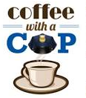Tuesday, July 31

8:30-10:00 AM

Sam Bowling

Conference Center

City National Bank

3601 MacCorkle Ave Se

Charleston, WV 25304

COFFEE WITH A COP

The mission of *coffee with a cop* is to break the barriers between police officers and the citizens they serve. – Providing the opportunity to ask questions or share what’s on their mind.

PLEASE JOIN US!

*SPONSORED BY:*

*The Kanawha County Community Association, The Charleston Police Department, and City National Bank*

