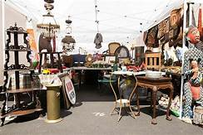  July 20, 2019  2019 SUMMER VINTAGE FLEA MARKET  Kanawha City Community Association presents:  We are excited to host our first Vintage inspired Flea Market! Always on the hunt for treasures, flea market shoppers love the joy of the hunt and the lure of the bargain. Unlike internet shopping, customers can touch, smell and closely examine merchandise to find that unique piece that brings back a special memory and personalizes a home. You are encouraged to ask questions and learn about what you are buying.  City Center East  4700 MacCorkle Ave SE, Charleston, WV 25304 | Prize Giveaways  ────  Antiques  ────  Vintage or Vintage inspired goods  ────  Unique collectibles and Crafts  ────  Repurposed Furniture  SATURDAY, JULY 20, 2019 10:00am – 6:00pm
*Vendor Spaces Available, for more information email us at Refurburator@aol.com

