BIKE-A-BOO
October 22, 2022
1:30PM – 3:30PM
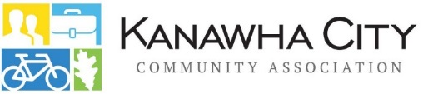
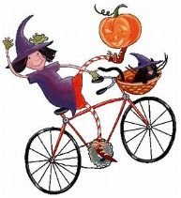
Kanawha City Rec Center at 3511 Venable Avenue
The Kanawha City Community Association is excited to host our 6th Annual Kanawha City Bike Appreciation Event for Kanawha City Residents.
This Family Fun Event is free to the public and includes:
- Bike giveaways for children ages 2-13
Must register between 1-1:30 only & must
be present to win a bike.

- Helmet Giveaways

- Charleston Police Department Obstacle Course

- Charleston Fire Department Smoke House

- Bike Tune-ups by Charleston Bicycle Center

- Lots of fun

- Bike Parade

- Kanawha-Charleston Humane Association (possible adoption event)
A bin will be provided for donations of food, blankets, etc.

More information can be found at www.kanawhacity.org
and the Kanawha City Community Association Facebook page

*This event is not endorsed by the Kanawha County Board of Education

